**– D I G H 402 –**

PROJECT BRAINSTORM

**ACTIONS:**

>> Weekly project log (ask Liz about splitting w/ reading responses)

**PYTHON RESOURCES:**

>> [Learn Python the Hard Way](https://learnpythonthehardway.org/book/)

>> [Code Academy](https://www.codecademy.com/learn/learn-python)

>> [Hands-On Python Tutorial (Harrington)](http://anh.cs.luc.edu/handsonPythonTutorial/)

>> [How to Think Like A Computer Scientist](http://interactivepython.org/courselib/static/thinkcspy/index.html)

>> [Automate the Boring Stuff with Python](https://automatetheboringstuff.com/)

**GitHub Options:**

<http://data.hackeducation.com/2017/07/28/how-to>

**CPS Reach Info:**

* <https://www.ctulocal1.org/rights/concerns/evaluation/reach101/>

**READINGS:**

[**https://nepc.colorado.edu/publication/schoolhouse-commercialism-2017**](https://nepc.colorado.edu/publication/schoolhouse-commercialism-2017)

“This year’s 19th annual report on schoolhouse commercialism trends examines how technological advances, the lure of “personalization,” and lax regulation foster the collection of personal data and have overwhelmed efforts to protect children’s privacy.” Not exactly what we talked about, but maybe an interesting area to explore, as it relates to student data

[**https://larrycuban.wordpress.com/2016/07/30/algorithms-in-use-evaluating-teachers-and-personalizing-learning-part-2/**](https://larrycuban.wordpress.com/2016/07/30/algorithms-in-use-evaluating-teachers-and-personalizing-learning-part-2/)

“In this post, I look first at those algorithms used to judge teachers’ effectiveness (or lack of it) and then I turn to ‘personalized learning’ algorithms customized for individual students.”

[**Methodological Concerns about the Education Value-Added Assessment System**](https://www.jstor.org/stable/30137966?Search=yes&resultItemClick=true&searchText=evaas&searchUri=%2Faction%2FdoBasicSearch%3FQuery%3Devaas&ab_segments=0%2Ftbsub-1%2Frelevance_config_with_defaults&refreqid=search%3Afd05afad5f287f19f204fd191fc75973&seq=1#metadata_info_tab_contents)

“She explores in depth the shortage of external reviews and validity studies of the model, its insufficient user-friendliness, and methodological issues about missing data, regression to the mean, and student background variables. She also examines a paradigm case in which the model was used to advance unfounded assertions.”

[**https://www.sas.com/en_us/software/evaas.html**](https://www.sas.com/en_us/software/evaas.html)

SAS EVAAS website→ interesting to see how they’re packing their product… also, [PDF of their released methodology and statistical models](https://www.sas.com/content/dam/SAS/en_us/doc/whitepaper1/sas-evaas-k12-statistical-models-107411.pdf)

[A Framework for Teacher Reflectivity by Claire Stanley](https://www-jstor-org.flagship.luc.edu/stable/3588129?Search=yes&resultItemClick=true&searchText=teacher&searchText=self-reflection&searchUri=%2Faction%2FdoBasicSearch%3FQuery%3Dteacher%2Bself-reflection&ab_segments=0%2Ftbsub-1%2Frelevance_config_with_defaults&refreqid=search%3A435d821a57a56d7c7ffaade060b81dee&seq=1#metadata_info_tab_contents)

[Illinois State Board of Ed: Assessments](https://www.isbe.net/Pages/Assessment.aspx)

[CPS Assessment Info](https://cps.edu/SchoolData/Pages/Assessment.aspx)

[Pasi Sahlberg: Excellence or Equity? [video]](https://youtu.be/3VX0m-BcMpY) speaks to the fact that equity and excellence correlate, but also uses a really simple but effective visual to explain it

[Teacher Evaluation in Chicago: Differences in Observation and Value-Added Scores by Teacher, Student, and School Characteristics](https://consortium.uchicago.edu/sites/default/files/publications/Teacher%20Evaluation%20in%20Chicago-Jan2016-Consortium.pdf)

[Data Modeling in a Digital Humanities Context](https://juliaflanders.files.wordpress.com/2016/08/flanders_jannidis_data_modeling.pdf)- considering DH methodologies for data modeling

[Digital Humanities Data Curation](https://guide.dhcuration.org/contents/data-representation/)- this is a fantastic guide for humanists working with data; the section on “Data Representation” might be especially relevant.

[Leading mathematician debunks “value-added”](https://www.washingtonpost.com/blogs/answer-sheet/post/leading-mathematician-debunks-value-added/2011/05/08/AFb999UG_blog.html?utm_term=.d7012a3085c6)

[TED talk: The era of blind faith in data must end](https://www.ted.com/talks/cathy_o_neil_the_era_of_blind_faith_in_big_data_must_end?utm_campaign=tedspread&utm_medium=referral&utm_source=tedcomshare)

[Value-Added Modeling 101](https://www.rand.org/education-and-labor/projects/measuring-teacher-effectiveness/value-added-modeling.html) (Rand Corporation)

[“The Potential Consequence of Using Value-Added Models to Evaluate Teachers”](https://files.eric.ed.gov/fulltext/EJ1158140.pdf)

[Can Value Added Add Value to Teacher Evaluation?](https://pdfs.semanticscholar.org/e12b/a1a01ab6374947775137d53b522c0738b8b7.pdf)

[Evaluating Teachers: The Important Role of Value-Added](https://www.brookings.edu/research/evaluating-teachers-the-important-role-of-value-added/) (Brookings)

[Report Finds Weak Link Between Value-Added Measures and Teacher Instruction](https://www.usnews.com/news/articles/2014/05/13/report-finds-weak-link-between-value-added-measures-and-teacher-instruction) (article linking to [study](https://journals.sagepub.com/stoken/rbtfl/Uwvo4Eg6.hQHI/full))

[Don’t Blame the Teachers](https://www.theatlantic.com/education/archive/2016/09/dont-blame-the-teachers/500552/)

[“The fundamental flaws of value-added teacher evaluation”](https://www.washingtonpost.com/news/answer-sheet/wp/2012/12/23/the-fundamental-flaws-of-value-added-teacher-evaluation/?noredirect=on&utm_term=.30dc0d3bb3cb) (Washington Post)

[“Student test scores: how the sausage is made, and why you should care”](https://www.brookings.edu/research/student-test-scores-how-the-sausage-is-made-and-why-you-should-care/)

[What schools could use instead of standardized tests](https://www.npr.org/sections/ed/2015/01/06/371659141/what-schools-could-use-instead-of-standardized-tests)

[New York State Teacher Self-Assessment Guide](http://usny.nysed.gov/rttt/teachers-leaders/practicerubrics/Docs/SilverStrongSelfAssessmentRubric.pdf)

[Self Evaluation of Teaching](https://www.ryerson.ca/content/dam/lt/resources/handouts/SelfEvaluation.pdf)

[Process Mining and clustering](https://learning.oreilly.com/library/view/data-mining-and/9781118998236/c01.xhtml)

[Weapons of Math Destruction](https://sakai.luc.edu/access/lessonbuilder/item/26603159/group/ELPS_555_001_6101_1192/Weekly%20Units/Mon%20March%2018%20--_chine%20Learning/555%20Cathy%20Oneil%20Weapons%20of%20Math%20Destruction%20excerpts%20SM.pdf)

**RELATED PROJECTS:**

>> [Gale’s Digital Scholar Lab](https://www.gale.com/primary-sources/digital-scholar-lab) as a tool for interrogating data

>> [Gender Pay Gap](https://www.theguardian.com/news/ng-interactive/2018/apr/04/gender-pay-gap-when-does-your-company-stop-paying-women-in-2018) (data visualization article)

>> [Changing the Math on Gerrymandering](https://thenib.com/changing-the-math-on-gerrymandering) (web comic analyzing data)

>> [Are You Reflected in the New Congress](https://www.theguardian.com/us-news/ng-interactive/2014/nov/06/-sp-congress-diversity-women-race-lgbt-are-you-represented) (semi-interactive)

>> [National Priorities Project](https://www.nationalpriorities.org/interactive-data/) (interactive data tools to see how your taxes were spent)

>> [The Calculus of Race And Class: A New Look at the Achievement Gap in New York City Schools](http://www.centernyc.org/calculus-of-race/)

>> [How Effective Is Your School District? A New Measure Shows Where Students Learn the Most](https://www.nytimes.com/interactive/2017/12/05/upshot/a-better-way-to-compare-public-schools.html)

>> [America’s Gradebook](http://apps.urban.org/features/naep/)

>> [Plickers](https://get.plickers.com/) (app that lets teachers quickly assess in-person student responses)

>> [Additio](https://www.additioapp.com/en/rubrics/) (app for students to self and peer assess w/ a rubric)

>> [Teacher Self-Assessment Tool](https://www.aitsl.edu.au/teach/improve-practice/teacher-self-assessment-tool)

>> [EvaluWise](https://itunes.apple.com/us/app/evaluwise-teacher-evaluation/id657406595?mt=8) (app for assessing teachers)

**[Research] questions to consider:**

Primary audience? Secondary? tertiary?

* Research on *content*→ Is there value in value-added data? How can teachers/students/parents interrogate their own/child’s data? What role do algorithms play in “personalized learning” software? How are schools/districts/testing companies using student data?
* Research on *form*→ What DH projects are utilizing innovative data visualization models?
* Research on *process*→ How can we subvert the traditional hierarchical structure of project management? How can we bring more awareness and inclusivity to both process and product?

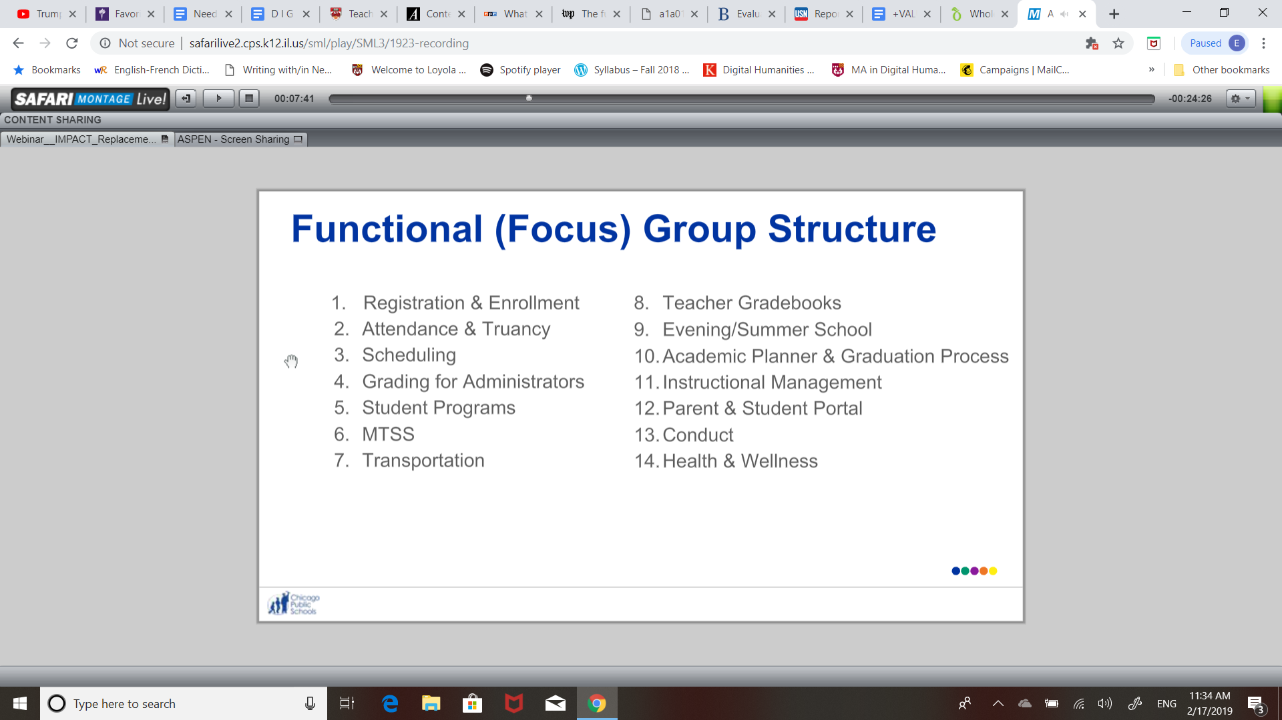

**THOUGHTS ON DELIVERABLE:**

Tool? Data visualization? Interrogation of data + conversation?

Dynamic journalistic exploration w/ interactive tool?

**RESEARCH FURTHER:**

* Dewey's research on reflective practice, studies showing its benefits